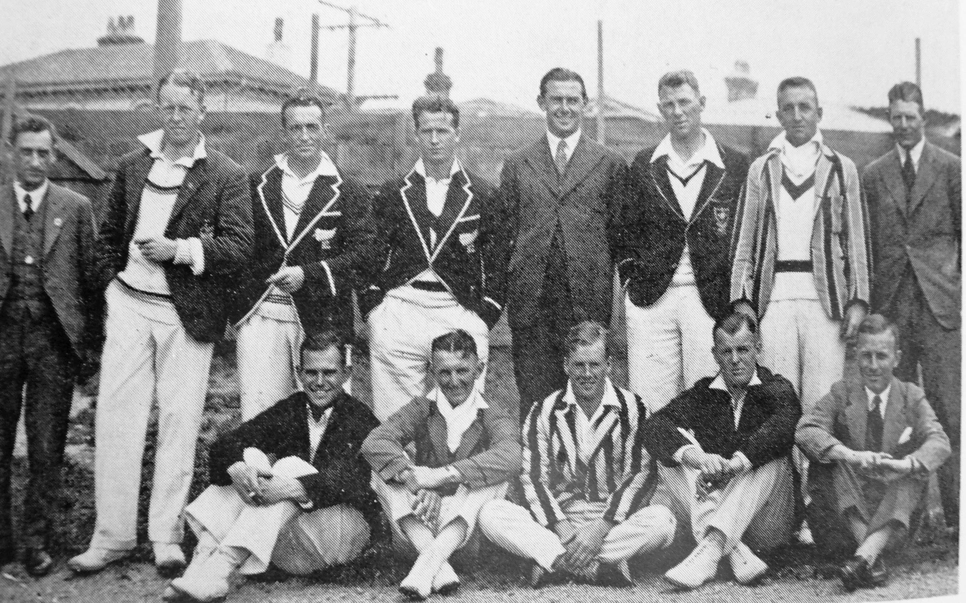

**Canterbury v Wellington 1 January 1932 Basin Reserve**

**Canterbury276 and 526/8 declared. Wellington 553 and 45/1. The match was drawn.**

**Back Row: T Thompson, SG Lester, ML Page, WE Merritt, IB Cromb, JT Burrows, RC Burns, JL Kerr**

**Front Row: AW Roberts, FWJ Bellamy, IM Hamilton, JL Powell, CG Crawford**